87-Unit Residential Units Approved for Johnson Road

https://parsippanyfocus.com/2021/01/12/87-unit-residential-units-approved-for-johnson-road/

The owner of 169 Johnson Road demolished the 33,736 square foot office building and will be replacing the structure with an 87-unit-three-story over a one-story parking garage. The two-story office building was known as Brevent Plaza. The application was approved on December 21, 2020.

The project was approved in the Parsippany-Troy Hills Fair Share Housing Center.

https://i0.wp.com/parsippanyfocus.com/wp-content/uploads/2021/01/building.jpeg?w=720&ssl=1

https://i0.wp.com/parsippanyfocus.com/wp-content/uploads/2021/01/169johnsonroad.jpeg?w=720&ssl=1

https://i0.wp.com/parsippanyfocus.com/wp-content/uploads/2021/01/site-169-johnson-road.jpeg?w=720&ssl=1
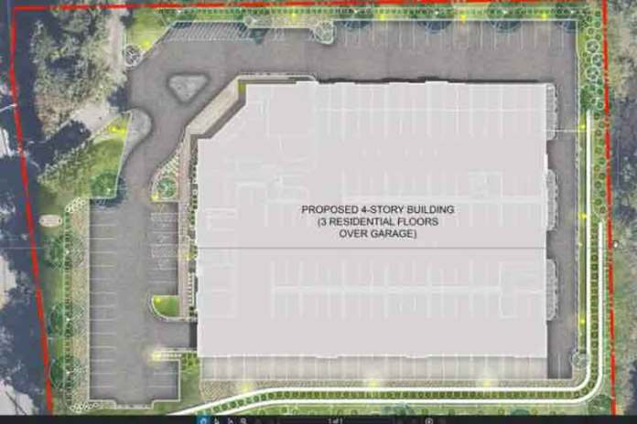

The complex will include 69 market-priced units and 18 affordable housing units.
The existing office building was constructed in 1982. The property is located on Block: 200 Lot: 8.
In April 2019, the Township executed a settlement agreement with the Fair Share Housing Center, to resolve litigation regarding Parsippany’s Prior and Third Round fair share affordable housing obligations. The agreement, which was accepted by the Court at a fairness hearing on June 21, 2019, sets forth the extent of the Township’s obligations and describes the compliance plan components by which Parsippany proposes to address those obligations. Part of this obligation has already been achieved in prior rounds, while other housing plan components will be undertaken through July 1, 2025, the end of the Third Round.
The Settlement Agreement identifies the following fair share obligations for the Township for the period from 1987 through July 1, 2025:
● Present Need (Rehabilitation Share): 190 units
● Prior Round (1987-1999) Obligation: 664 units
● Third Round (1999-2025) Obligation: 1,314 units

